Sample | Drawings | Ware type | Date | Glaze colours  T – transparent  SC – semi-covering  FC – full covering
1 | 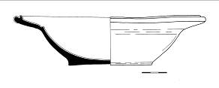 | bowl | 16th century | SC ochre, sprinkled brown
2 | 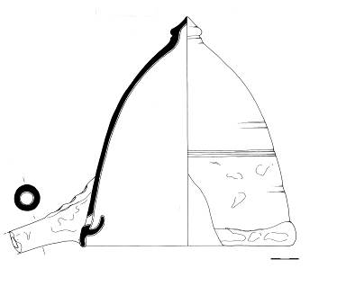 | distillation lid | 2/2 15th – ½ 16th century | SC green
3 | 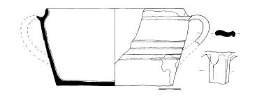 | bowl | 2/2 15th – ½ 16th century | SC green
4 | 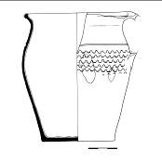 | pot | 2/2 15th – ½ 16th century | SC ochre
5 | 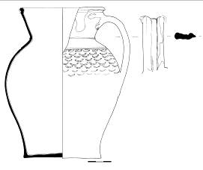 | jug | 2/2 15th – ½ 16th century | SC ochre  brown
6 | 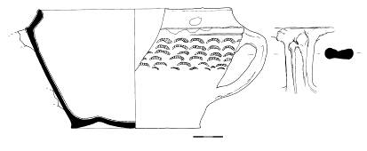 | bowl | 2/2 15th – ½ 16th century | SC ochre brown
7 | 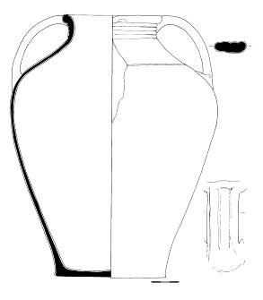 | jar | 2/2 15th – ½ 16th century | SC green
8 | 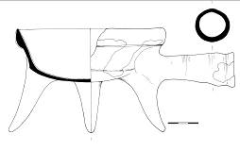 | pipkin | 2/2 15th – ½ 16th century | SC ochre brown
9 | 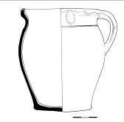 | pot | 2/2 15th – ½ 16th century | SC brown
10 | 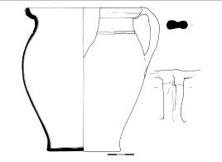 | pot | 2/2 15th – ½ 16th century | SC brown (to the green)
11 | 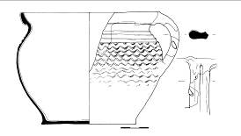 | pot | 2/2 15th – ½ 16th century | T sprinkled brown
12 | 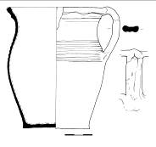 | pot | 16th century | SC green
13 | 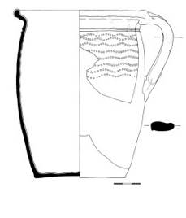 | pot | 2/2 16th – ½ 17th century | SC green
14 | 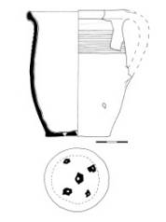 | small pot | 2/2 16th – ½ 17th century | SC ochre yellow
15 | 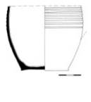 | pot | 2/2 16th – ½ 17th century | SC ochre brown
16 | 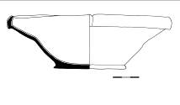 | bowl | 2/2 16th – ½ 17th century | SC ochre brown
17 | 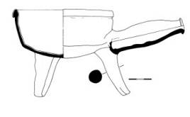 | pipkin | 2/2 16th – ½ 17th century | SC ochre brown
18 | 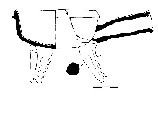 | pipkin | 2/2 16th – ½ 17th century | T (colour of ceramic body)
19 | 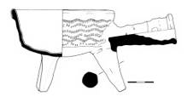 | pipkin | 2/2 16th – ½ 17th century | SC ochre yellow
20 |  | pipkin | 2/2 16th – ½ 17th century | T sprinkled ochre brown
21 | 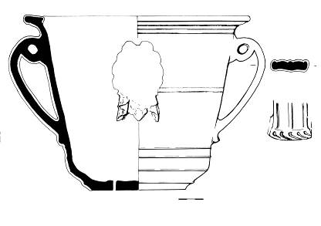 | flowerpot | 2/2 16th – ½ 17th century | SC green
22 | 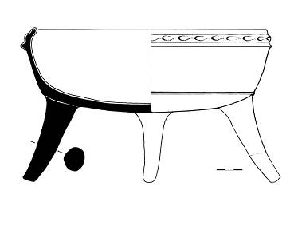 | pipkin | 2/2 16th – ½ 17th century | SC ochre yellow
23 | 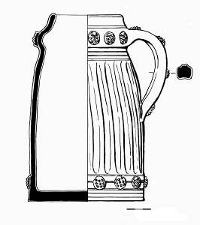 | beerstein/  mag | 2/2 16th – ½ 17th century | inside SC yellow  outside FC brown
24 | 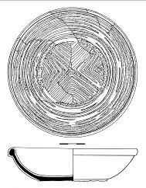 | bowl | 2/2 16th – ½ 17th century | FC yellow decor
25 | 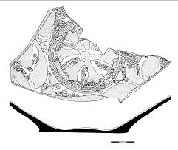 | bowl | 2/2 16th – ½ 17th century | FC green, brickcolour
26 | 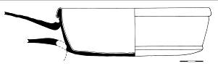 | pipkin | 2/2 16th – ½ 17th century | SC ochre
27 | 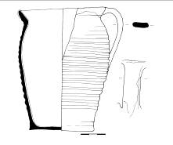 | pot | 2/2 17th – ½ 18th century | FC brown
28 | 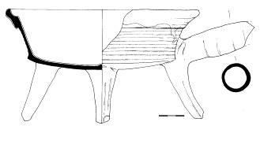 | pipkin | 2/2 17th – ½ 18th century | SC green
29 | 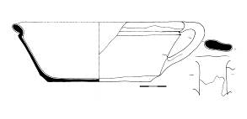 | bowl | 2/2 17th – ½ 18th century | SC ochre, sprinkled green
30 | 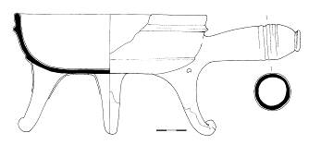 | pipkin | 2/2 17th – ½ 18th century | FC brown-black
31 | 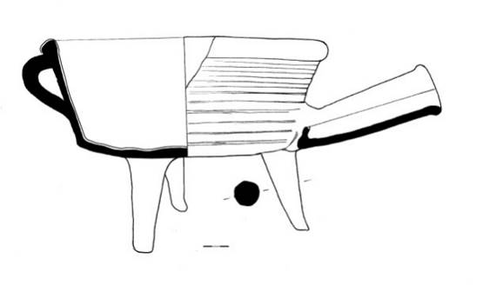 | pipkin | 2/2 17th – ½ 18th century | FC ochre-brown
32 | 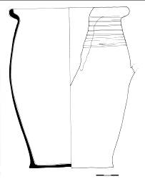 | pot | 2/2 17th – ½ 18th century | FC orange-ochre
33 | 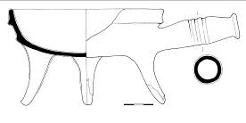 | pipkin | 2/2 17th – ½ 18th century | SC light green
34 | 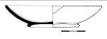 | small bowl | 2/2 17th – ½ 18th century | FC green-black
35 | 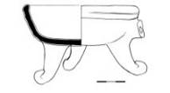 | pipkin | 2/2 17th – ½ 18th century | FC brown-black
36 | 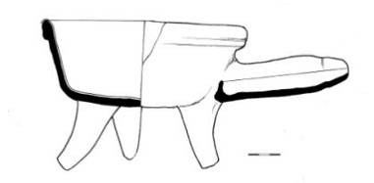 | pipkin | 2/2 17th – ½ 18th century | FC brown
37 | 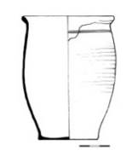 | pot | 2/2 17th – 1/3 18th century | edge SC light green  inside SC yellow
38 | 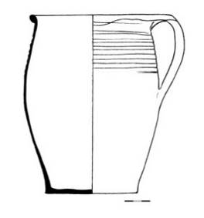 | pot | 2/2 17th – 1/3 18th century | edge FC brown  inside SC yellow
39 | 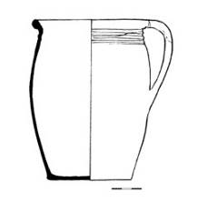 | pot | 2/2 17th – 1/3 18th century | edge SC green  inside SC yellow
40 | 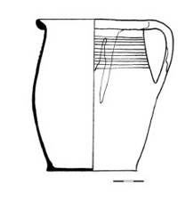 | pot | 17th century | edge SC green  inside SC yellow

